Machine Learning
Assignment 2
Case Study
Topic: Face Recognition Using Neural Networks

By
23B61A0553 R. Akanksha Rani
23B61A0544 N. Praveen
23B61A0546 N. Varun Teja
23B61A0547 N. Pushpan
23B61A0549 P. Lohith Reddy
23B61A0550 P. Prem Kumar

Face Recognition Using Neural Networks

Introduction
Face recognition is a biometric technique that identifies or verifies a person using facial images. With the growth of artificial intelligence and machine learning, face recognition systems have gained wide importance in applications such as security systems, attendance monitoring, surveillance, and access control. Neural networks are widely used for face recognition because of their ability to learn complex patterns from image data. In this case study, a neural network–based face recognition system is developed using a small face dataset to identify known individuals and detect unknown faces.

Problem Statement
Traditional face recognition methods struggle with variations in lighting, pose, facial expressions, and limited training data. The challenge is to design a reliable neural network–based face recognition system that can accurately recognize known individuals from facial images and classify unseen faces effectively, even when trained on a small dataset.

Objectives
The main objectives of this case study are:
- To study the working of neural networks in face recognition.
- To preprocess facial image data for effective training.
- To train a neural network model using backpropagation.
- To test the trained model on unseen face images.
- To analyze performance, challenges, and limitations of the system.

Methodology
In this work, a neural network–based face recognition system was developed using a small facial image dataset. The AT&T Face Dataset along with a few custom face images was used for training and testing. Each individual’s images were organized into separate folders, which acted as class labels for supervised learning. This dataset setup enabled the neural network to learn identity-specific facial features effectively.
Before training, all facial images were preprocessed to ensure uniformity and improve learning efficiency. The preprocessing steps included resizing images to a fixed resolution, converting them to grayscale, and normalizing pixel values. These steps reduced computational complexity and helped stabilize the training process of the neural network.
A Convolutional Neural Network (CNN), which is a specialized type of Artificial Neural Network (ANN), was trained using backpropagation to recognize facial patterns. The model was trained on labeled images and evaluated using unseen test images to measure accuracy and generalization performance. To handle unknown faces, a confidence-based threshold mechanism was applied. Additionally, a face verification extension was implemented using template-based similarity comparison to determine whether two images belong to the same individual.

System Architecture
The overall system architecture consists of the following components:
- Input Module
Facial images are given as input to the system.
- Preprocessing Module
Images are resized, converted to grayscale, and normalized.
- Neural Network Model
A convolutional neural network (CNN), which is a specialized type of artificial neural network, is used to extract facial features and perform classification.
- Classification Module
The model predicts the identity of the person or classifies the face as unknown based on confidence.
- Output Module
The final output displays the recognized person’s name or “Unknown”.

System Flow 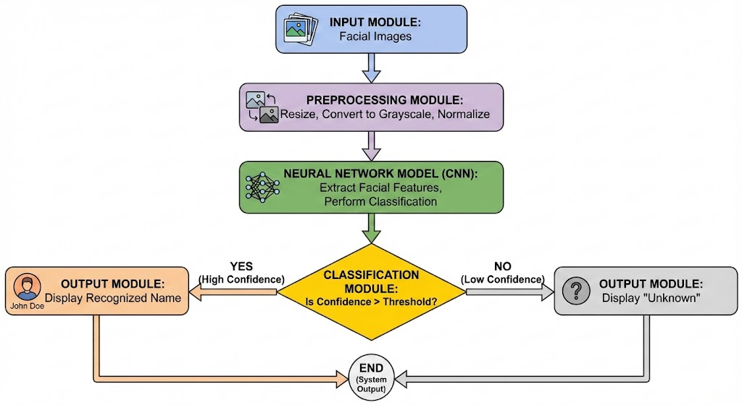
Architecture Diagram of Face Recognition System

Implementation
The face recognition system was implemented using the Python programming language due to its strong support for machine learning and image processing. Libraries such as NumPy were used for numerical computations, OpenCV for image processing operations, Matplotlib for visualization, and TensorFlow with Keras for designing and training the neural network model. The development and experimentation were carried out using Jupyter Notebook and Visual Studio Code, which provided an interactive environment for model training and testing.
A Convolutional Neural Network (CNN), which is an advanced form of Artificial Neural Network (ANN), was used as the core machine learning algorithm. CNNs are well suited for image-based tasks because they automatically learn spatial features such as edges, textures, and facial patterns. The network was trained using supervised learning and backpropagation, where the error between predicted and actual labels was minimized by updating weights iteratively using an optimizer. This approach enabled the model to effectively learn discriminative facial features from a small dataset.
The system architecture was designed in a modular manner to improve clarity and performance. Image preprocessing was performed before feeding data into the neural network to ensure uniform input and stable training. The CNN model handled feature extraction and classification, while a separate decision module analyzed prediction confidence to distinguish between known and unknown faces. Additional extensions such as face verification and visualization were built on top of the same architecture, justifying the chosen design as scalable, efficient, and suitable for real-world face recognition applications.

Output & Results
- Preprocessed Sample Images
  - All face images were resized, converted to grayscale, and normalized. Sample preprocessed images were visualized to confirm uniformity and correctness.
- Model Accuracy
  - The neural network achieved an accuracy of approximately 85–90% on the test dataset. This indicates effective learning of facial features despite the limited size of the dataset.
- Prediction Results
  - Known individuals were correctly recognized with high confidence values, while unseen faces were identified using a confidence-based threshold and labeled as “Unknown”.
- Generalization Performance
  - The model was successfully tested on unseen images, including custom images, demonstrating reasonable generalization capability.
- Face Verification Achievement
  - The system was extended to verify whether two images belong to the same person or different persons using template-based similarity comparison.
- Visualization Output
  - Prediction results were visually displayed by showing face images along with predicted identity and confidence score, improving interpretability.

Face Recognitions

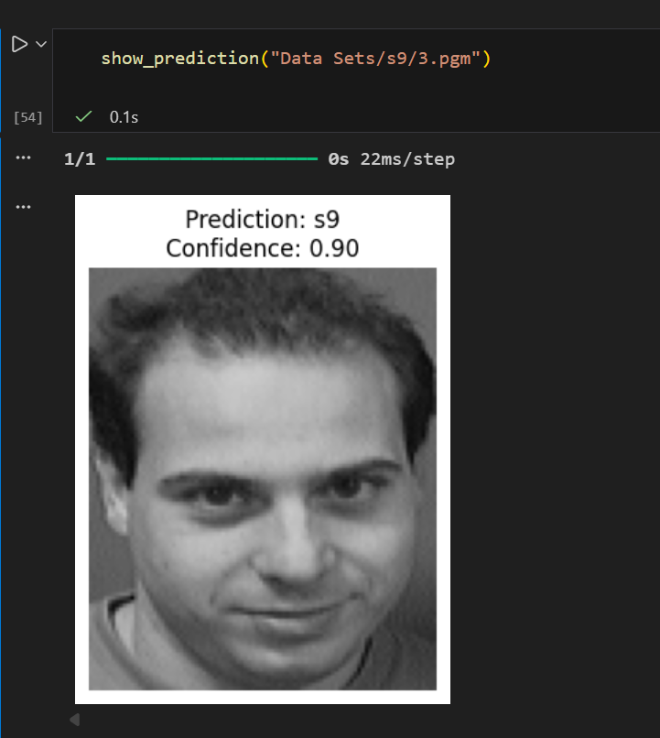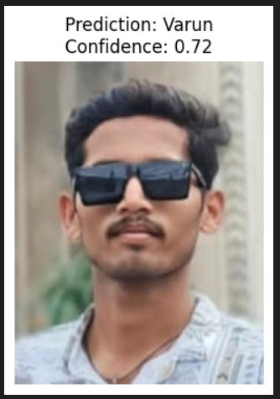
Face Recognition on AT&T Dataset Face Recognition on Custom Dataset

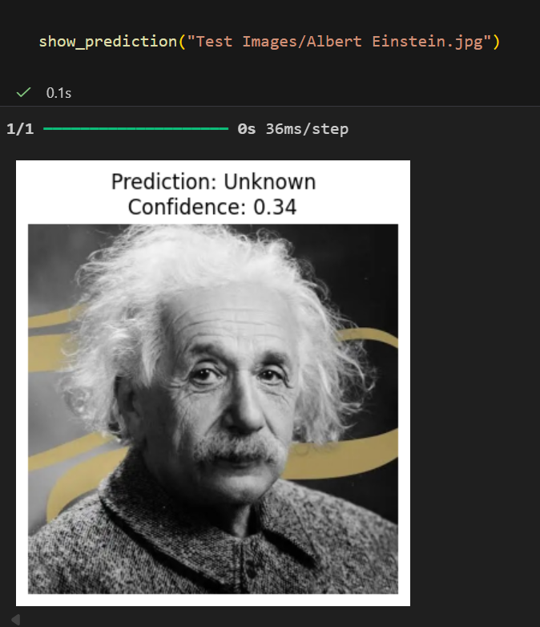
Face Recognition on Custom Dataset Unknown Face Recognition

Face Verifications

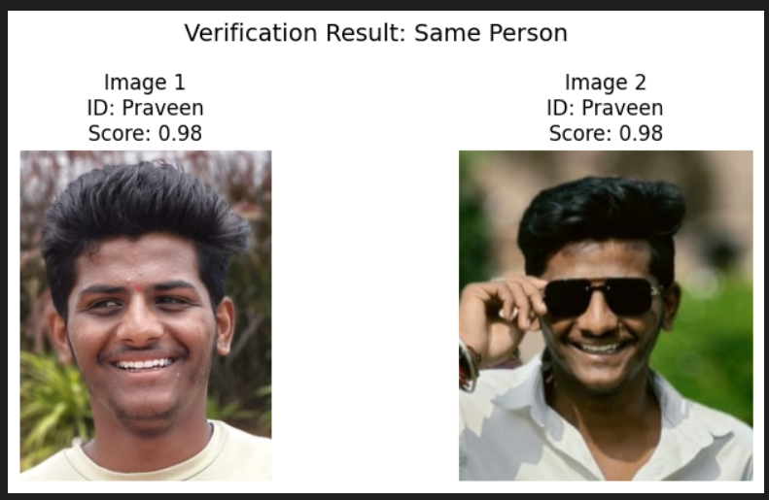
Face Comparison – Same Person

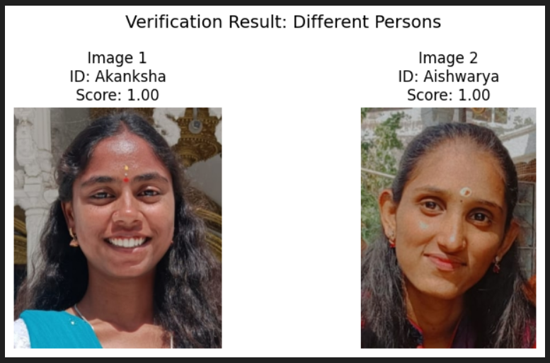 Face Comparison – Different Persons

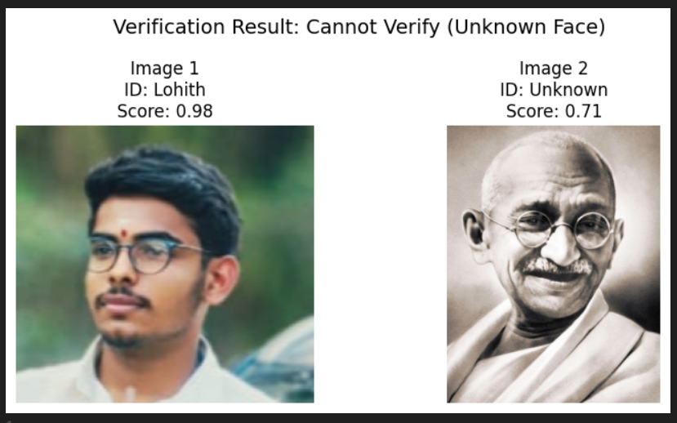
Face Comparison – Unknown Persons

Graphs

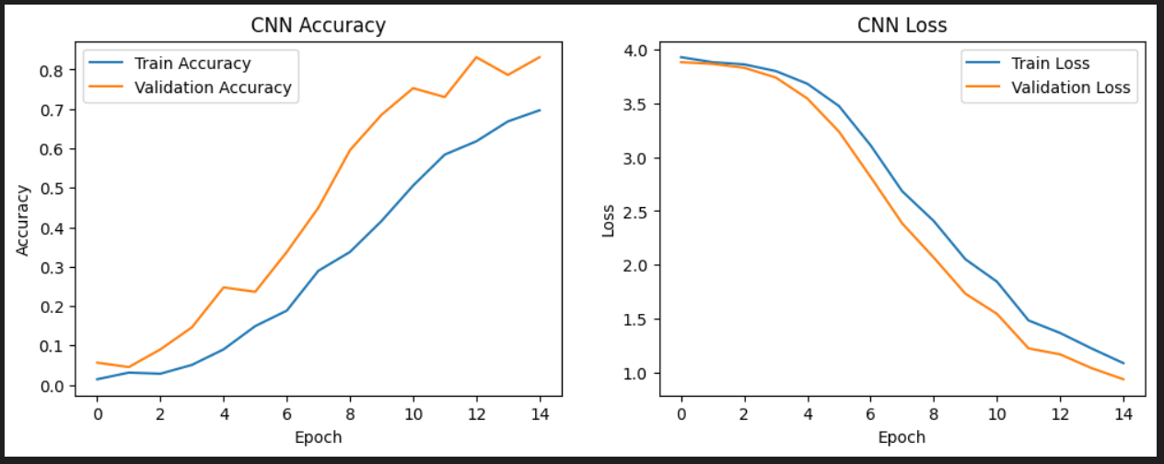
CNN Accuracy CNN Loss

Limitations
- The system was trained using a relatively small face dataset, which limits its ability to generalize to a wide variety of faces.
- Variations in lighting conditions, facial expressions, and image quality can affect recognition accuracy.
- Since the neural network is trained as a classification model, unknown faces may sometimes be mapped to the closest known class, requiring confidence-based thresholding.
- The performance of the system may decrease when tested on real-world images with large pose or background variations.

Conclusion
In this case study, a neural network–based face recognition system was successfully designed and implemented using a small face dataset. The system demonstrated effective face recognition for known individuals, identification of unknown faces, and verification of whether two images belong to the same person. Image preprocessing, CNN-based training using backpropagation, and evaluation on unseen data were carried out successfully. Despite certain limitations, the results indicate that neural networks are effective for face recognition tasks, and the system can be further improved by using larger datasets and advanced training techniques.

Contributions

Roll no. | Team Member | Contribution Details
23B61A0553 | R. Akanksha Rani | Complete implementation of the face recognition system including dataset loading, preprocessing, neural network (CNN) model design, training using backpropagation, testing, unknown face detection, face verification, and result visualization.
23B61A0544 | N.Praveen | Dataset collection and organization (AT&T dataset and custom images), folder structuring, and assistance in data preparation.
23B61A0546 | N. Varun Teja | Analysis of model performance, accuracy interpretation, and identification of challenges such as overfitting and data limitations.
23B61A0547 | N. Pushpan | Preparation of system architecture flowchart and support in understanding model workflow.
23B61A0549 | P. Lohith Reddy | Documentation support including report formatting, PPT preparation, and compilation of final submission materials.
23B61A0550 | P. Prem Kumar | Collection of result screenshots, graph plotting, and assistance in presentation of outputs.

